Glaucoma Detection Using Convolutional Neural Networks

# Nishant Bhushan C*, Kumaran R*, Nitheesh Kumar P*, S.A.K. Jainulabudeen**

* UG Students, Computer Science and Engineering, Panimalar Engineering college, Chennai, India.

** Assistant Professor, Department of CSE, Panimalar Engineering college, Chennai, India.

***Abstract-*** *Glaucoma is often linked to a build-up of pressure inside the eyes. Glaucoma tends to run in families and one usually doesn’t get it until later in life. The increased pressure in eyes, called intraocular pressure, can damage the optic nerve, which sends images to the brain. If the damage worsens, glaucoma can cause permanent vision loss or even total blindness within a few years. Most people with glaucoma have no early symptoms or pain. One must visit the eye doctor regularly so they can diagnose and treat glaucoma before one has long-term vision loss. If a person loses his vision, it can’t be brought back. But, lowering eye pressure can help keep the sight that he has. Most people with glaucoma who follow their treatment plan and have regular eye exams are able to keep their vision. Glaucoma is a chronic and irreversible eye disease, which leads to deterioration in vision and quality of life. we develop a Deep Learning (DL) with convolutional neural network for automated glaucoma diagnosis. Deep learning systems, such as convolutional neural networks (CNNs), can infer a hierarchical representation of images to discriminate between glaucoma and non-glaucoma patterns for diagnostic decisions. The model is trained with the ROI of RIGA, DRISHTI-GS1 dataset. The Network architecture used gives great accuracy. A graphical user interface is used to diagnose the condition of test images and give a graphical analysis of the patients.*

***Keywords****-*Glaucoma Detection, DRISHTI-GS1, Tensor Flow, Keras API.

# INTRODUCTION

Glaucoma is one of the most hazardous ocular diseases. It is a set of disorders, categorized mostly by high intraocular pressure (IOP) causing damage to the optic nerve. According to the World Health Organization it is second foremost cause of blindness worldwide. Glaucoma is also known as snitch thief of sight because resembling a hushed slayer it usually has no indicators till permanent vision loss occurs. Glaucoma is often linked to a build-up of pressure inside the eyes. Glaucoma tends to run in families and one usually doesn’t get it until later in life. The increased pressure in eyes, called intraocular pressure, can damage the optic nerve, which sends images to the brain. If the damage worsens, glaucoma can cause permanent vision loss or even total blindness within a few years. Most people with glaucoma have no early symptoms or pain. One must visit the eye doctor regularly so they can diagnose and treat glaucoma before one has long-term vision loss. If a person loses his vision, it can’t be brought back. But, lowering eye pressure can help keep the sight that he has. Most people with glaucoma who follow their treatment plan and have regular eye exams are able to keep them. research paper in a journal. Deep learning models (DL) can learn spatial structural information and uncover new biomarkers related to glaucoma by directly analyzing 3D Optical Coherence Tomography (OCT) volumes. Deep learning systems, such as convolutional neural networks (CNNs), can infer a hierarchical representation of pictures from which glaucoma and non-glaucoma patterns can be distinguished for diagnostic purposes. The ROI of RIGA, DRISHTI-GS1 dataset is used to train the model. The network architecture employed provides excellent precision. To diagnose the condition of test photographs, a graphical user interface is employed. The dataset DRISHTI-GS1 consists of a total of 101 images. It is divided into 50 training and 51 testing images. And the Extra thousands of images for additional training are taken from the Kaggle website.

# II. LITERATURE SURVEY

It's [1]“Detection of Glaucoma Using Retinal Fundus Images” Hafsah Ahmad, Abubakar Yamin, Aqsa Shakeel, Syed Omer Gillani, Umer Ansari(IEEE 2014) . This paper proposes an image processing technique for the detection of glaucoma which mainly affects the optic disc by increasing the cup size. During early stages it was difficult to detect Glaucoma, which is in fact second leading cause of blindness. In this paper glaucoma is categorized through extraction of features from retinal fundus images. The features include (i) Cup to Disc Ratio (CDR), which is one of the primary physiological parameters for the diagnosis of glaucoma and (ii) Ratio of Neuroretinal Rim in inferior, superior, temporal and nasal quadrants i.e. (ISNT quadrants) for verification of the IS NT rule. The novel technique is implemented on 80 retinal images and an accuracy of 97.5% is achieved taking an average computational time of 0.8141 seconds.

[2]“Automatic Glaucoma Detection by Using Funduscopic Images”, Atheesan S., Yashothara S.(IEEE 2016). Glaucoma is a group of related eye disorders that cause damage to the optic nerve that carries information from the eye to the brain which can get worse over time and lead to blindness. It is very important that glaucoma is detected as early as possible for proper treatment. In this paper, we have proposed a Convolutional Neural Network (CNN) system for early detection of Glaucoma. Initially, eye images are augmented to generate data for Deep learning. The eye images are then pre- processed to remove noise using Gaussian Blur technique and make the image suitable for further processing. The system is trained using the pre-processed images and when new input images are given to the system it classifies them as normal eye or glaucoma eye based on the features extracted during training.

[3]”Automated Detection of Suspected Glaucoma in Digital Fundus Images”, Namita Sengar, Malay Kishore Dutta, Radim Burget, Martin Ranjoha(IEEE 2017) Glaucoma is the Second leading causes of blindness across the world, it is an eye disease that affects the retina and optic nerve of eye which carries signals to the eye. This disease can lead to permanent blindness if not treated at earlier stage. The increased intraocular pressure which is main cause of glaucoma damages the optic nerve which sends images to the brain, the diameter of the optic cup within optic disc region is increased due to this increased retinal pressure. The increased cup to disc ratio (CDR) results in the loss of optic nerve fibers that are connected to the retina by disc area. CDR is the important structural features for differentiating between healthy and a glaucomatous eye. The objective of this paper is to present review of methods for automated detection of Glaucoma from fundus images of eye that assist in the progressive development of computer aided systems.

[4] Budai A, Bock R, Maier A, Hornegger J, Michelson G. Robust vessel segmentation in fundus images. Int J Biomed Imag. 2013. One of the most common modalities to examine the human eye is the eyefundus photograph. The evaluation of fundus photographs is carried out by medical experts during time-consuming visual inspection. Our aim is to accelerate this process using computer aided diagnosis. As a first step, it is necessary to segment structures in the images for tissue differentiation. As the eye is the only organ, where the vasculature can be imaged in an in vivo and noninterventional way without using expensive scanners, the vessel tree is one of the most interesting and important structures to analyze. The quality and resolution of fundus images are rapidly increasing. Thus, segmentation methods need to be adapted to the new challenges of high resolutions. In this paper, we present a method to reduce calculation time, achieve high accuracy, and increase sensitivity compared to the original Frangi method. This method contains approaches to avoid potential problems like specular reflexes of thick vessels. The proposed method is evaluated using the STARE and DRIVE databases and we propose a new high resolution fundus database to compare it to the state-of-the-art algorithms. The results show an average accuracy above 94% and low computational needs. This outperforms state-of-the-art methods.

[5] Simonyan K, Zisserman A. Very deep convolutional networks for large scale image recognition. 2014. ArXiv e-prints arxiv:abs/1409.1556 In this work we investigate the effect of the convolutional network depth on its accuracy in the large-scale image recognition setting. Our main contribution is a thorough evaluation of networks of increasing depth using an architecture with very small ( 3 × 3) convolution filters, which shows that a significant improvement on the prior-art configurations can be achieved by pushing the depth to 16–19 weight layers. These findings were the basis of our ImageNet Challenge 2014 submission, where our team secured the first and the second places in the localization and classification tracks respectively. We also show that our representations generalize well to other datasets, where they achieve state-of-the-art results. We have made our two best performing ConvNet models publicly available to facilitate further research on the use of deep visual representations in computer vision the foremost preliminary step for proceeding with any research work writing. While doing this go through a complete thought process of your Journal subject and research.

[6] “A Comprehensive Retinal Image Dataset for the Assessment of Glaucoma from the Optic Nerve Head Analysis” Jayanthi Sivaswamy, S.R.Krishnadas, Arunava Chakravarty, Gopal Datt Joshi, Ujjwal1 and Tabish Abbas Syed. In this work we investigated on All of the photographs were taken with the cooperation of visitors to Aravind Eye Hospital in Madurai. Glaucoma is a disease that affects the eyes. Clinical investigators chose patients based on a variety of factors. Observations made during the examination Patients between the ages of 40 and 60 were chosen. Males and females are about equal in age at 80 years old. Patients who get a regular refraction test and are not found to be deficient, we have glaucoma. All photos were collected with the eyes dilated using the following data collection protocol: centered on OD with a Field of View of 30-degrees and a resolution of 2896 x 1944 pixels; The image format PNG is uncompressed. There are no other options. The acquisition procedure was subjected to imaging limitations. Four glaucoma patients supplied ground truth for each image. professionals with more than three years' experience. Poor-quality photos were deleted due to poor contrast, OD region location, and other factors. Fundus area (image region) is included in this dataset. The original has been retrieved (containing retinal structures). By removing the non-fundus mask zone surrounding the image a 2047 x 1760-pixel picture.

# III. WORKING OF THE PROPOSED SYSTEM

The pre-processed image is given as an input to the CNN model which consists of an input layer, convolution layers and a fully connected layer. The input image of 256x256pixel acts as the input layer. In the first convolution layer, 16 filters of 3x3 size kernels each are applied to the input image by gliding one by one through the position and a total of 16 feature maps are generated. This method is called as feature extraction.

These features are then applied to the ReLU activation function, which performs a threshold operation for each input variable with values below zero. On the output of the ReLU layer, a max pooling layer of 2x2 window size is applied which results in down-sampling of the feature maps to 128x128 pixel*.*

System architecture is the conceptual model that defines the structure, behavior, and more views of a system. An architecture description is a formal description and representation of a system, organized in a way that supports reasoning about the structures and behaviors of the system.

**Database:**

Database The database contains total 2000 eye images for training and testing. Out of 2000 images, 1500 images contain glaucoma and 500 images are healthy (without glaucoma). • All the images are of varying sizes and in different formats.

The dataset DRISHTI-GS1 consists of a total of 101 images. It is divided into 50 training and 51 testing images. And the Extra thousands of images for additional training are taken from the Kaggle website.

**Classification:**

Classification The process of classification is to classify an image according to its visual content. The classifier used is k-nearest neighbors. The number of neighbors (k), distance matrix and dataset is given as an input for the algorithm.

Input image

Pre-processing

Filtering

Normalization

Patch Extraction

Feature Extraction

CNN Classification

Estimation

Glaucoma Input Image

Test feature

Train feature

Labels

Sensitivity

Glaucoma Specificity

Fig 1. Work Flow Diagram of Glaucoma Detection

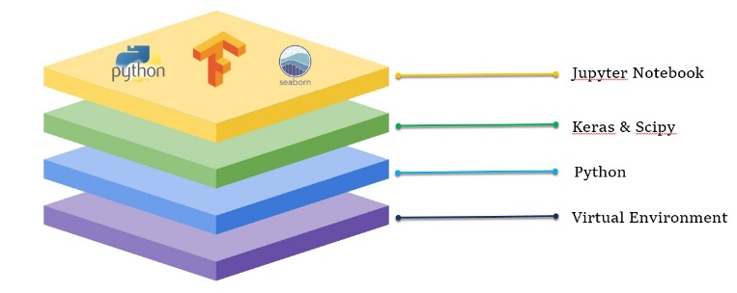

Fig 2. Technology Stack

**IV. IMPLEMENTATION**

With the implantation of TensorFlow Framework and Keras model for deep learning and training the model, the level of precision of the Glaucoma detection has unavoidably improved. When an image is uploaded into the system, it is compared to the model that has already been trained and then processed.

In the implementation of the glaucoma the images can be classified into the two dataset such as the images with glaucoma and images without glaucoma

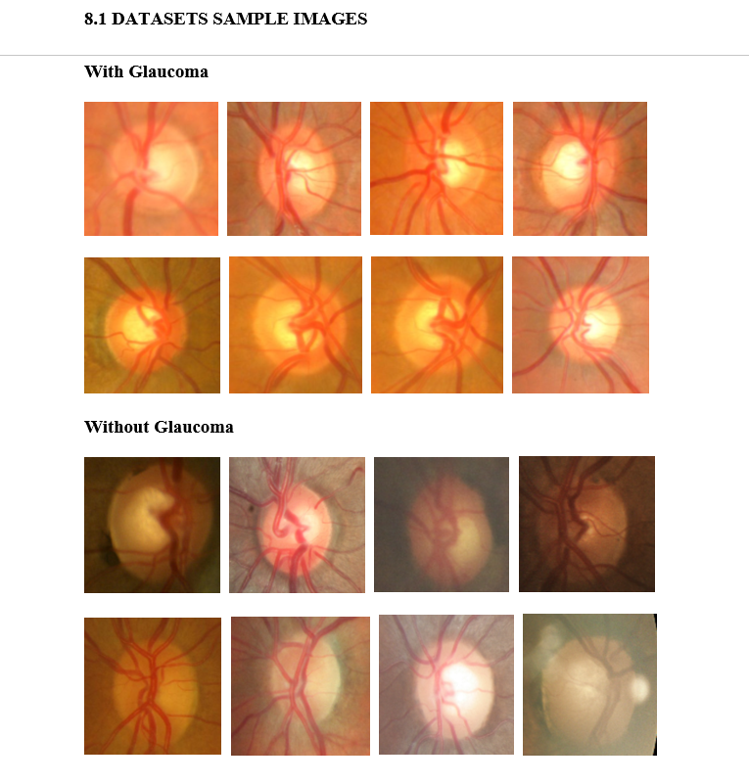

Fig 3. Images With Glaucoma and Without Glaucoma

While processing the input portraits, the system compares them to existing datasets of over 2000 glaucoma and non-glaucoma snaps and provides an accurate result.

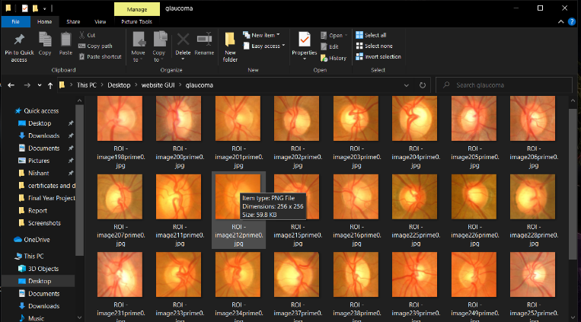



Fig 4.Dataset Images

To communicate with the software, we created a Web UI. The technology allows you to take eye portraits as well as allow users to upload their own images, which are then analysed and displayed to show the existence of Glaucoma.

The web UI is the user interface it shows the users whether the person is affected by glaucoma or not and the examples images are given below.

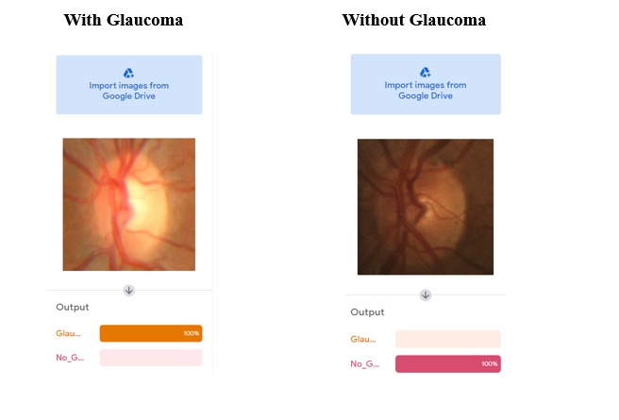

Fig 5.Sample Output with and without glaucoma

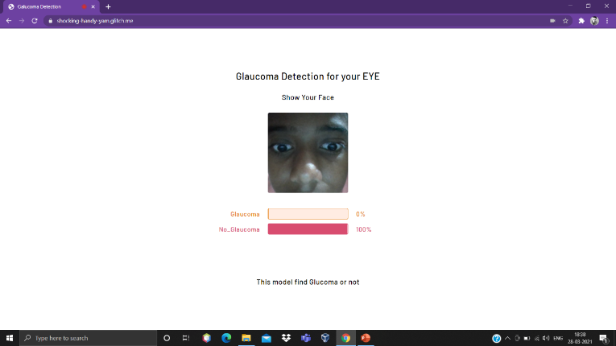

Fig 6. Web UI

**V.CONCLUSION**

Glaucoma is a “silent thief of sight” having no early symptoms and can cause permanent blindness if not detected or diagnosed at an early stage. Fundoscopy enables ophthalmologists to analyze the internal retinal structural changes i.e. change in CDR, ISNT ratio. Regular retinal layer analysis is a fundamental need to prevent glaucoma or stop glaucoma progression. Research is being done in biomedical imaging to propose algorithms for CAD systems which aids doctors in analyzing and screening the affected patients. Many autonomous glaucoma detection systems help in early detection of glaucoma by analyzing the structural changes in the internal retina. CDR, ISNT ratio, NRR ratio, Vertical and horizontal Cup height are the fundamental structural changes that appear in case of glaucoma progression and are being analyzed by all the autonomous glaucoma detection systems. Many state of art Machine learning techniques are also being used in glaucoma detection systems which uses textural and intensity based features to discriminate healthy eyes from glaucomatous eyes. Proposed methodology provides an algorithm to detect glaucoma by analyzing the structural changes from fundus image and correlate the results with classification results from machine learning module. This hybrid of structural changes based evaluation and machine learning based evaluation results in more accurate results and improves the sensitivity to 1. Images labeled as healthy or non-healthy by both the modules are classified as healthy or non-healthy respectively. If the results from both modules do not converge at a decision, image is classified as suspect. Glaucoma detected cases and suspects are referred to ophthalmologists for further examination and medication. Proposed system is able to screen out glaucoma patients 100 % accuracy as none of the glaucoma case is classified as normal.

**VI. REFERENCE**

[1]“Detection of Glaucoma Using Retinal Fundus Images” Hafsah Ahmad, Abubakar Yamin, Aqsa Shakeel, Syed Omer Gillani, Umer Ansari(IEEE 2014).

[2]“Automatic Glaucoma Detection by Using Funduscopic Images”, Atheesan S., Yashothara S.(IEEE 2016).

[3]”Automated Detection of Suspected Glaucoma in Digital Fundus Images”, Namita Sengar, Malay Kishore Dutta, Radim Burget, Martin Ranjoha(IEEE 2017) .

[4] Budai A, Bock R, Maier A, Hornegger J, Michelson G. Robust vessel segmentation in fundus images. Int J Biomed Imag. 2013.

[5]Simonyan K, Zisserman A. Very deep convolutional networks for largescale image recognition. 2014. ArXiv e-prints arxiv:abs/1409.1556.

[6]Carneiro G, NascimentoJ, Bradley AP. In : Navab N, Hornegger J, Wells WM, Frangi AF, eds. Unregistered multiview mammogram analysis with pre-trained deep learning models.

[7]World Health Organization. Bulletin of the World Health Organization, Volume 82(11). 2004.

[8] Bourne RRA. Worldwide glaucoma through the looking glass. Br J Ophthalmol.2006

. [9]Bock R, Meier J, Nyúl LG, Hornegger J, Michelson G. Glaucoma risk index: automated glaucoma detection from color fundus images. Med Image Anal. 2010.